SOP -on OEM agent restart
How to check the agent path:-

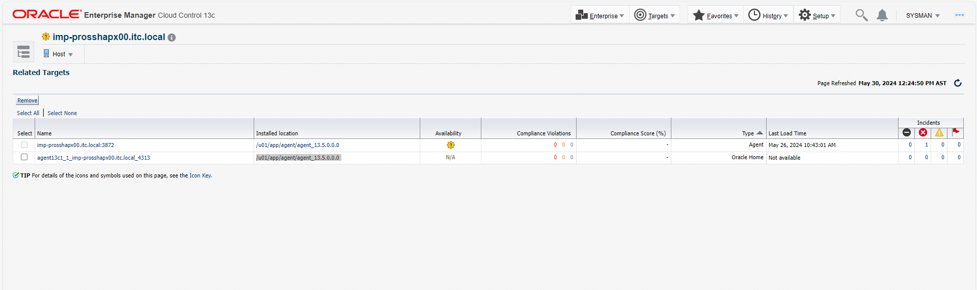

How to restart form cli :-
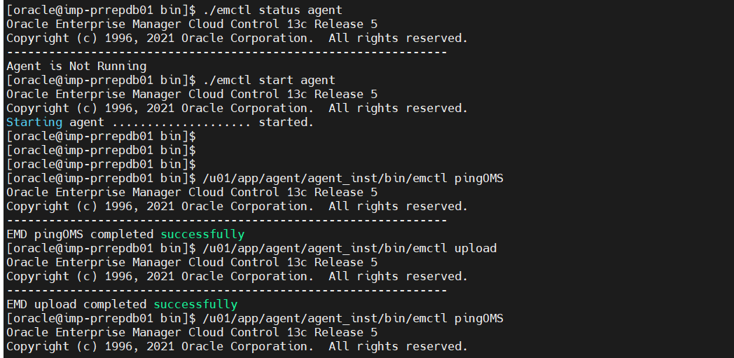

If agent is up and running fine, but showing warning on the OEM portal, please follow the below.
[oemuser@imp-prosbhapxy01 ~]$ cd /u01/app/agent/agent_13.5.0.0.0/bin/
[oemuser@imp-prosbhapxy01 bin]$ ./emctl status agent
Oracle Enterprise Manager Cloud Control 13c Release 5
Copyright (c) 1996, 2021 Oracle Corporation. All rights reserved.
---------------------------------------------------------------
Agent Version : 13.5.0.0.0
OMS Version : (unknown)
Protocol Version : 12.1.0.1.0
Agent Home : /u01/app/agent/agent_inst
Agent Log Directory : /u01/app/agent/agent_inst/sysman/log
Agent Binaries : /u01/app/agent/agent_13.5.0.0.0
Core JAR Location : /u01/app/agent/agent_13.5.0.0.0/jlib
Agent Process ID : 1825
Parent Process ID : 1788
Agent URL : https://imp-prosbhapx00.itc.local:3872/emd/main/
Local Agent URL in NAT : https://imp-prosbhapx00.itc.local:3872/emd/main/
Repository URL : https://imp-ppoemapp02.itc.local:4903/empbs/upload
Started at : 2024-05-29 08:55:47
Started by user : oemuser
Operating System : Linux version 5.4.17-2136.330.7.1.el8uek.x86_64 (amd64)
Number of Targets : 3
Last Reload : (none)
Last successful upload : (none)
Last attempted upload : (none)
Total Megabytes of XML files uploaded so far : 0
Number of XML files pending upload : 477
Size of XML files pending upload(MB) : 0.61
Available disk space on upload filesystem : 72.30%
Collection Status : Collections enabled
Heartbeat Status : Agent is blocked
Blocked Reason : Agent is out-of-sync with repository. This most likely means that the agent was reinstalled or recovered. Please contact an EM administrator to unblock the agent by performing an agent resync from the console.
Last attempted heartbeat to OMS : 2024-05-30 12:35:04
Last successful heartbeat to OMS : (none)
Next scheduled heartbeat to OMS : 2024-05-30 12:38:04

---------------------------------------------------------------
Agent is Running and Ready
[oemuser@imp-prosbhapxy01 bin]$ ip -br a
lo UNKNOWN 127.0.0.1/8 ::1/128
enp1s0 UP 172.20.2.132/23 172.20.2.99/23
enp2s0 UP 172.20.10.72/25 172.20.10.38/25
[oemuser@imp-prosbhapxy01 bin]$
[oemuser@imp-prosbhapxy01 bin]$
[oemuser@imp-prosbhapxy01 bin]$ /u01/app/agent/agent_inst/bin/emctl pingOMS
Oracle Enterprise Manager Cloud Control 13c Release 5
Copyright (c) 1996, 2021 Oracle Corporation. All rights reserved.
---------------------------------------------------------------
EMD pingOMS error: The agent is blocked by the OMS. Agent is out-of-sync with repository. This most likely means that the agent was reinstalled or recovered. Please contact an EM administrator to unblock the agent by performing an agent resync from the console.
[oemuser@imp-prosbhapxy01 bin]$ ./emctl secure agent
Oracle Enterprise Manager Cloud Control 13c Release 5
Copyright (c) 1996, 2021 Oracle Corporation. All rights reserved.
Agent successfully stopped... Done.
Securing agent... Started.
Enter Agent Registration Password :
Agent successfully restarted... Done.
Securing agent... Successful.
[oemuser@imp-prosbhapxy01 bin]$
[oemuser@imp-prosbhapxy01 bin]$
[oemuser@imp-prosbhapxy01 bin]$
Contact sys admin for the agent registration password: -infra team.

[oemuser@imp-prosbhapxy01 bin]$ /u01/app/agent/agent_inst/bin/emctl pingOMS
Oracle Enterprise Manager Cloud Control 13c Release 5
Copyright (c) 1996, 2021 Oracle Corporation. All rights reserved.
---------------------------------------------------------------
EMD pingOMS error: The agent is blocked by the OMS. Agent is out-of-sync with repository. This most likely means that the agent was reinstalled or recovered. Please contact an EM administrator to unblock the agent by performing an agent resync from the console.
[oemuser@imp-prosbhapxy01 bin]$ /u01/app/agent/agent_inst/bin/emctl upload
Oracle Enterprise Manager Cloud Control 13c Release 5
Copyright (c) 1996, 2021 Oracle Corporation. All rights reserved.
---------------------------------------------------------------
EMD upload error:full upload has failed: The agent is blocked by the OMS. Agent is out-of-sync with repository. This most likely means that the agent was reinstalled or recovered. Please contact an EM administrator to unblock the agent by performing an agent resync from the console. (AGENT_BLOCKED)
[oemuser@imp-prosbhapxy01 bin]$
[oemuser@imp-prosbhapxy01 bin]$
[oemuser@imp-prosbhapxy01 bin]$

Unblock from GUI:-
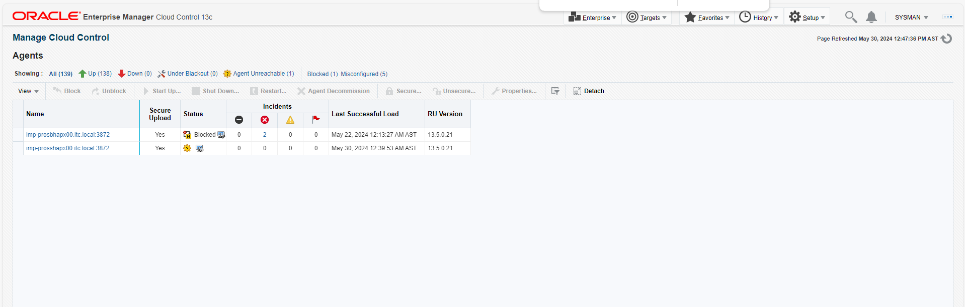

ast login: Wed May 29 08:55:33 +03 2024
[oemuser@imp-prosbhapxy01 ~]$
[oemuser@imp-prosbhapxy01 ~]$
[oemuser@imp-prosbhapxy01 ~]$ cd /u01/app/agent/agent_13.5.0.0.0/bin/
[oemuser@imp-prosbhapxy01 bin]$ ./emctl status agent
Oracle Enterprise Manager Cloud Control 13c Release 5
Copyright (c) 1996, 2021 Oracle Corporation. All rights reserved.
---------------------------------------------------------------
Agent Version : 13.5.0.0.0
OMS Version : (unknown)
Protocol Version : 12.1.0.1.0
Agent Home : /u01/app/agent/agent_inst
Agent Log Directory : /u01/app/agent/agent_inst/sysman/log
Agent Binaries : /u01/app/agent/agent_13.5.0.0.0
Core JAR Location : /u01/app/agent/agent_13.5.0.0.0/jlib
Agent Process ID : 1825
Parent Process ID : 1788
Agent URL : https://imp-prosbhapx00.itc.local:3872/emd/main/
Local Agent URL in NAT : https://imp-prosbhapx00.itc.local:3872/emd/main/
Repository URL : https://imp-ppoemapp02.itc.local:4903/empbs/upload
Started at : 2024-05-29 08:55:47
Started by user : oemuser
Operating System : Linux version 5.4.17-2136.330.7.1.el8uek.x86_64 (amd64)
Number of Targets : 3
Last Reload : (none)
Last successful upload : (none)
Last attempted upload : (none)
Total Megabytes of XML files uploaded so far : 0
Number of XML files pending upload : 477
Size of XML files pending upload(MB) : 0.61
Available disk space on upload filesystem : 72.30%
Collection Status : Collections enabled
Heartbeat Status : Agent is blocked
Blocked Reason : Agent is out-of-sync with repository. This most likely means that the agent was reinstalled or recovered. Please contact an EM administrator to unblock the agent by performing an agent resync from the console.
Last attempted heartbeat to OMS : 2024-05-30 12:35:04
Last successful heartbeat to OMS : (none)
Next scheduled heartbeat to OMS : 2024-05-30 12:38:04

---------------------------------------------------------------
Agent is Running and Ready
[oemuser@imp-prosbhapxy01 bin]$ ip -br a
lo UNKNOWN 127.0.0.1/8 ::1/128
enp1s0 UP 172.20.2.132/23 172.20.2.99/23
enp2s0 UP 172.20.10.72/25 172.20.10.38/25
[oemuser@imp-prosbhapxy01 bin]$
[oemuser@imp-prosbhapxy01 bin]$
[oemuser@imp-prosbhapxy01 bin]$ /u01/app/agent/agent_inst/bin/emctl pingOMS
Oracle Enterprise Manager Cloud Control 13c Release 5
Copyright (c) 1996, 2021 Oracle Corporation. All rights reserved.
---------------------------------------------------------------
EMD pingOMS error: The agent is blocked by the OMS. Agent is out-of-sync with repository. This most likely means that the agent was reinstalled or recovered. Please contact an EM administrator to unblock the agent by performing an agent resync from the console.
[oemuser@imp-prosbhapxy01 bin]$ ./emctl secure agent
Oracle Enterprise Manager Cloud Control 13c Release 5
Copyright (c) 1996, 2021 Oracle Corporation. All rights reserved.
Agent successfully stopped... Done.
Securing agent... Started.
Enter Agent Registration Password :
Agent successfully restarted... Done.
Securing agent... Successful.
[oemuser@imp-prosbhapxy01 bin]$
[oemuser@imp-prosbhapxy01 bin]$
[oemuser@imp-prosbhapxy01 bin]$
[oemuser@imp-prosbhapxy01 bin]$
[oemuser@imp-prosbhapxy01 bin]$ /u01/app/agent/agent_inst/bin/emctl pingOMS
Oracle Enterprise Manager Cloud Control 13c Release 5
Copyright (c) 1996, 2021 Oracle Corporation. All rights reserved.
---------------------------------------------------------------
EMD pingOMS error: The agent is blocked by the OMS. Agent is out-of-sync with repository. This most likely means that the agent was reinstalled or recovered. Please contact an EM administrator to unblock the agent by performing an agent resync from the console.
[oemuser@imp-prosbhapxy01 bin]$ /u01/app/agent/agent_inst/bin/emctl upload
Oracle Enterprise Manager Cloud Control 13c Release 5
Copyright (c) 1996, 2021 Oracle Corporation. All rights reserved.
---------------------------------------------------------------
EMD upload error:full upload has failed: The agent is blocked by the OMS. Agent is out-of-sync with repository. This most likely means that the agent was reinstalled or recovered. Please contact an EM administrator to unblock the agent by performing an agent resync from the console. (AGENT_BLOCKED)
[oemuser@imp-prosbhapxy01 bin]$
[oemuser@imp-prosbhapxy01 bin]$
[oemuser@imp-prosbhapxy01 bin]$ /u01/app/agent/agent_inst/bin/emctl stop agent
Oracle Enterprise Manager Cloud Control 13c Release 5
Copyright (c) 1996, 2021 Oracle Corporation. All rights reserved.
Stopping agent ... stopped.
[oemuser@imp-prosbhapxy01 bin]$ /u01/app/agent/agent_inst/bin/emctl start agent
Oracle Enterprise Manager Cloud Control 13c Release 5
Copyright (c) 1996, 2021 Oracle Corporation. All rights reserved.
Starting agent ............ started.
[oemuser@imp-prosbhapxy01 bin]$ u01/app/agent/agent_inst/bin/emctl pingOMS
-bash: u01/app/agent/agent_inst/bin/emctl: No such file or directory
[oemuser@imp-prosbhapxy01 bin]$ /u01/app/agent/agent_inst/bin/emctl pingOMS
Oracle Enterprise Manager Cloud Control 13c Release 5
Copyright (c) 1996, 2021 Oracle Corporation. All rights reserved.
---------------------------------------------------------------
EMD pingOMS completed successfully
[oemuser@imp-prosbhapxy01 bin]$ /u01/app/agent/agent_inst/bin/emctl upload
Oracle Enterprise Manager Cloud Control 13c Release 5
Copyright (c) 1996, 2021 Oracle Corporation. All rights reserved.
---------------------------------------------------------------
EMD upload completed successfully
[oemuser@imp-prosbhapxy01 bin]$

